|  |  |  |
| --- | --- | --- |
| Taylor Sloan | CSCI 251, Bob Robertson | MWF 2:00-3:30 |
|  |  |  |

1. Text, whiteboard

   Description automatically generated
   1. This works because import random allows the random function to be used. The random.choice then chooses a random item from myList
2. Graphical user interface, application

   Description automatically generated
3. Graphical user interface, application

   Description automatically generated
4. 1, 0, -1, 0, 1, 2, 3, 4, 5, 6
5. Graphical user interface, application

   Description automatically generated
6. Graphical user interface, text, application, Word

   Description automatically generated
   1. See above
   2. Using the end = “, “ essentially replaces the normal end of a break, meaning that a lot more numbers can fit on the screen without overflowing. Each print is now separated by a comma and space instead of a line break.
   3. Text

      Description automatically generated
7. Screenshots. I added colors
   1. Graphical user interface, application

      Description automatically generated
   2. A picture containing text, silhouette

      Description automatically generated
   3. A picture containing text, screenshot

      Description automatically generated
   4. A picture containing text, silhouette

      Description automatically generated
8. Screenshots
   1. Graphical user interface

      Description automatically generated
   2. Graphical user interface, application

      Description automatically generated
   3. A picture containing text, silhouette

      Description automatically generated
9. Screenshots
   1. Graphical user interface, application

      Description automatically generated
   2. A picture containing text, smoke, air, chain

      Description automatically generated
   3. A picture containing text, accessory, chain, locket

      Description automatically generated
10. Screenshots
    1. 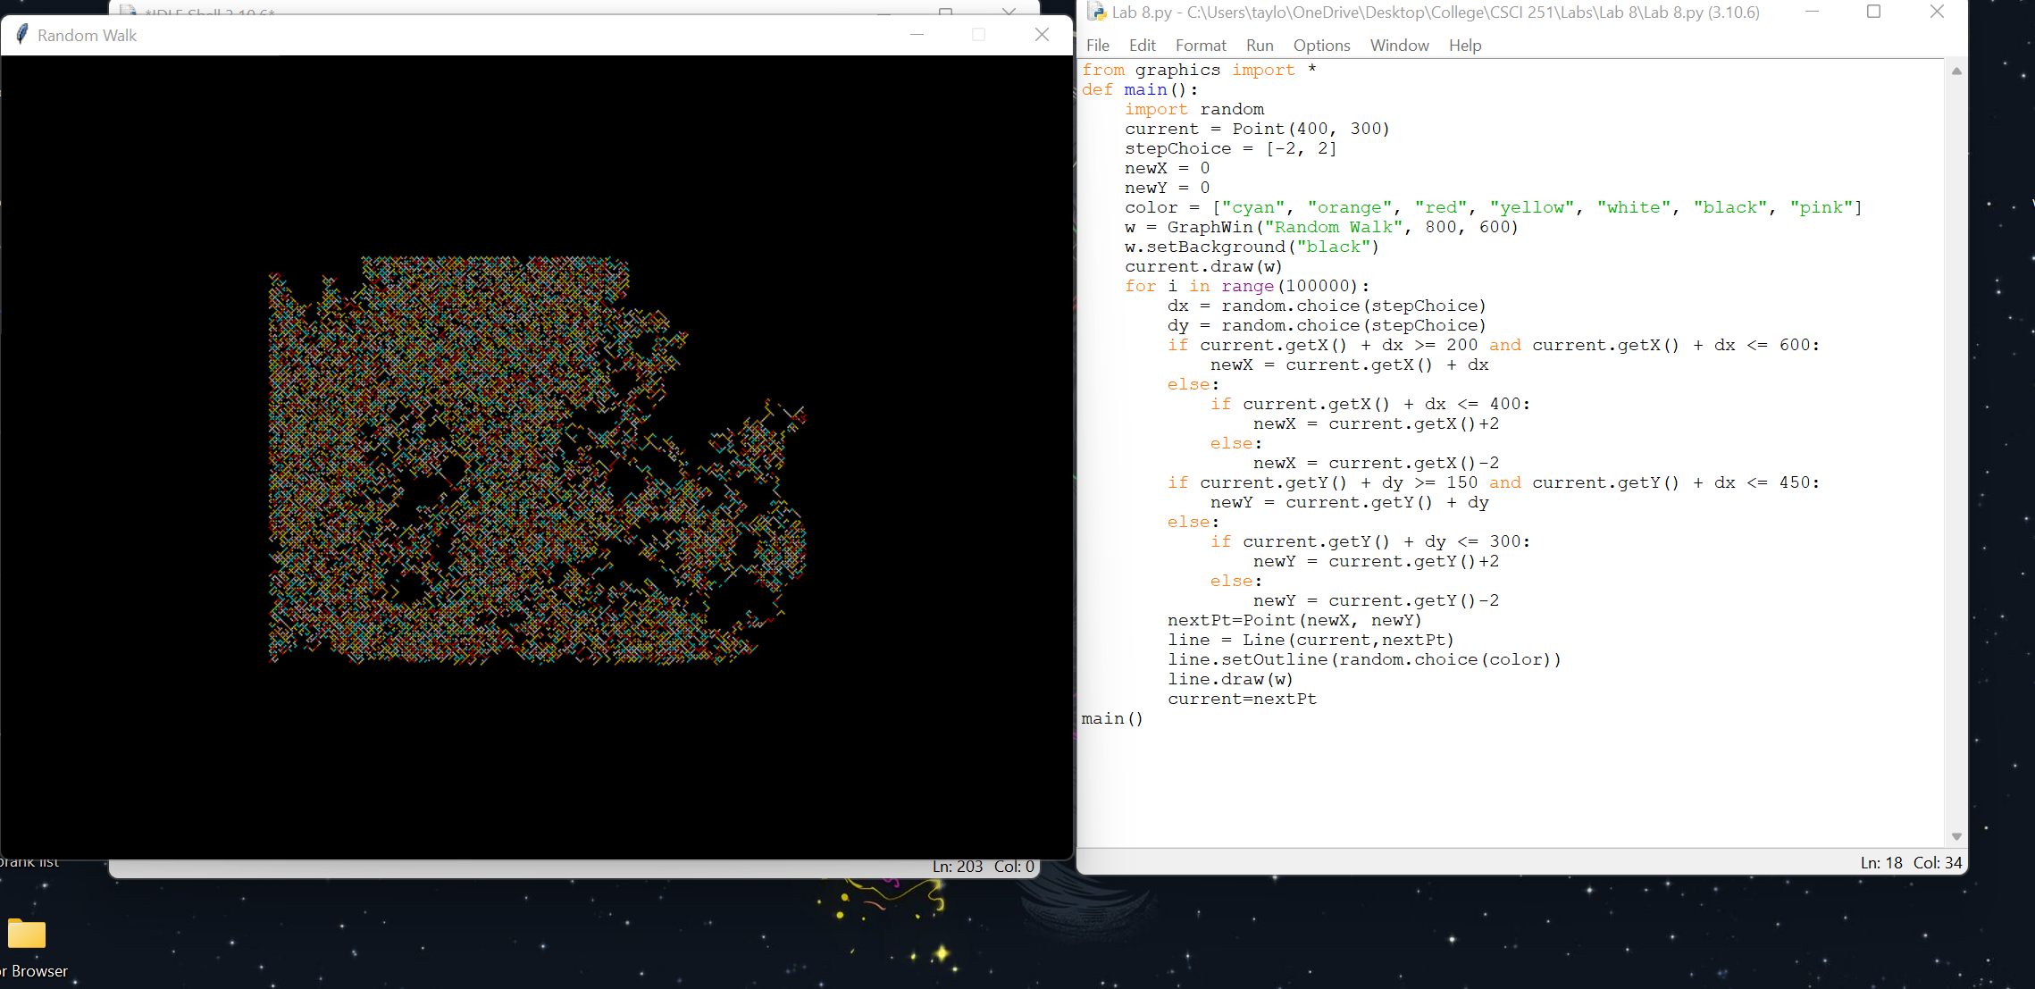
    2. A picture containing text, screenshot

       Description automatically generated
    3. Map

       Description automatically generated
11. Screenshots
    1. 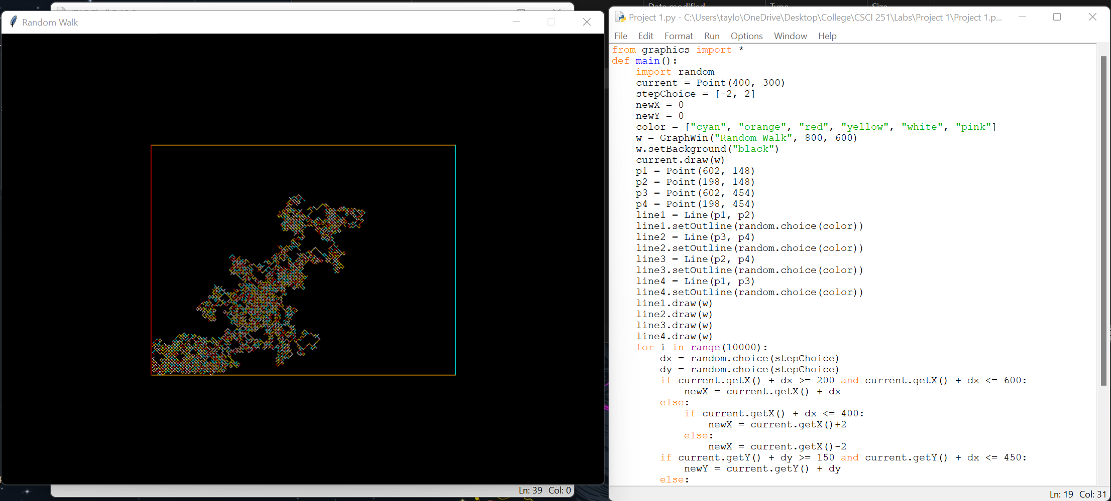
    2. Graphical user interface

       Description automatically generated
    3. A computer screen capture

       Description automatically generated with low confidence